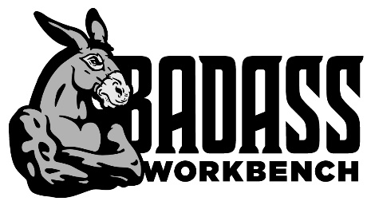
ELF Enterprises Inc. dba Badass Workbench
2608 E 32nd St Place, Kearney NE 68847
Toll Free 866-547-1123 sales@badass-workbench.com
Congratulations! Your order has shipped!
Please read entirely through the information below in regards to your shipment.
We have requested the freight company to call and arrange delivery with you. Please make sure you are on-site to receive your shipment during your scheduled time, failure to do so will result in an additional charge from the freight company. You are responsible for unloading your own freight and you will need a forklift. Carriers charge extra for additional services. Keep in mind if you require these services after we have received a rate from the carrier and shipped your order, you will be responsible for the extra costs if we receive any additional charges.
Examples of added services:
- Request driver assistance for unloading
- Driver waits longer than 30 minutes to be unloaded
- Calling ahead, or rescheduled appointments
- No Access for a 53ft semi-truck
- Construction site, school, utility company, airport, government secured areas, non-commercial addresses, residential homes, gated communities, lift gate delivery, rural delivery

Examples of how your shipment should look upon receiving: 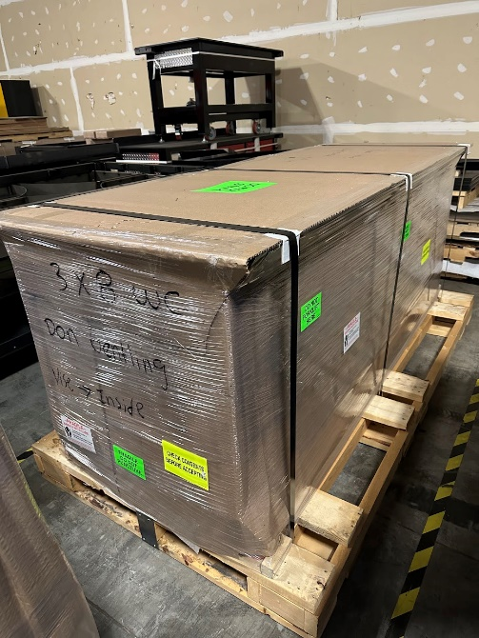 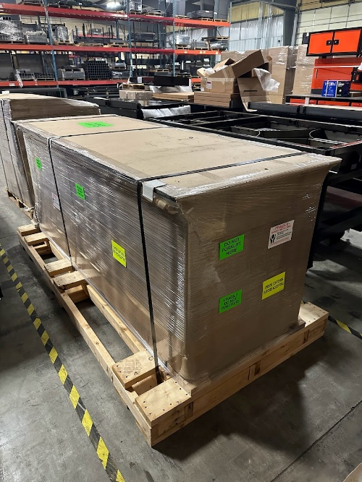

- COUNT AND INSPECT FREIGHT BEFORE UNLOADING SHIPMENT
Make sure the number of pieces matches the driver’s copy. Take time to inspect all freight for damage. It is very important these details are checked. If the driver leaves without proper notes on the driver’s copy, we will NOT be able to dispute with the carrier. Even if the package looks okay and there is any torn, ripped, dented, or crushed cardboard, torn stretch wrap, ANYTHING, please notate it on the the driver’s copy of the BOL.

- MISSING PIECES? NOTE ON THE DRIVERS RECEIPT
If there is something missing (for example: “1 skid missing, vise missing, etc”) notate the driver’s copy. Contact us and we will assist the carrier in locating the lost items and reship if necessary.

- DAMAGE? NOTE THE DRIVER’S RECEIPT
You may refuse or accept a damaged shipment. If there is damage, write the number of pieces damaged and describe the damage to the product (for example: scuffed paint, broken casters, punctured side, bent pegboard, dented frame, crushed corner etc) beside or near your signature on the driver’s copy. If a pallet looks tampered with, opened, or repackaged notate it on the driver’s copy. On the driver’s copy DO NOT check the box “shrink wrap intact”, DO NOT declare a dollar value.

- TAKE PHOTOS OF DAMAGE
Take photos of the entire damage BEFORE Unloading. Take photos of the entire damage and close-ups of damaged products and or crates/packaging and email it to us at sales@badassworkbench.us
Save all damaged packaging and product, carriers will inspect later. Packaging/product must be kept for up to 180 days.

- CONTACT US TO REPORT THE MISSING/DAMAGED FREIGHT
TOLL FREE 866-547-1123 / sales@badass-workbench.com
In the likely event that your workbench shows up in perfect condition, please share photos with us once you have it in place! We love seeing our Badass Products in action! Thanks again for your order, we truly appreciate your business and we look forward to hearing from you.
Sincerely,
The Badass Workbench Team!

